The Basic Ten
The building blocks of Pilates that focus on the abdominals and back muscles.
A Fitness Pilates sequence for beginners/intermediate exercisers. Repeat each exercise 4-10 times.

 | Exercise name | Exercise execution | Notes
1 | Pelvic Curl to low bridge | 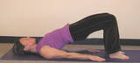 | Lying supine in a neutral spine position, legs parallel, knees bent, feet relaxed, arms by side.  Inhale: No movement  Exhale: draw abdominals in and curl pelvis and spine off the mat.  Inhale: No movement  Exhale: roll the spine down to starting position.
2 | Supine Spine Twist | 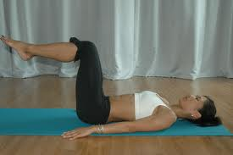 | Lying supine, arms in T position palms facing up, legs in tabletop.  Inhale: Lower legs to one side  Exhale: Draw abdominals in and return to starting position
3 | Chest Lift | 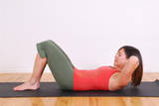 | Lying supine in a neutral spine position, knees bent, feet relaxed, fingers interlaced behind head.  Inhale: No movement  Exhale: Lift head and chest  Inhale: Pause  Exhale: Lower head and chest to starting position  Progression: Hundreds
4 | Roll down and up | 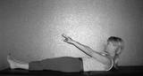 | Starting sitting, knees bent or straight.  Inhale: No movement  Exhale: Draw abdominals in and start to roll back to the floor.  Inhale: Pause  Exhale: Draw abdominals in and roll up to sitting position.
5 | Spine stretch | 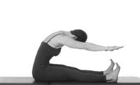 | Sitting straight, legs straight, legs shoulder width apart.  Inhale: No movement  Exhale: roll down taking head towards knees.  Inhale: Extend arms forward, palms facing each other. Extend forwards.  Exhale: Return to rolled down position and release arms.  Inhale: Restack the spine as roll up to starting position.
6 | Side lifts | 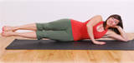 | Lying on side, bottom arm straight or bent with head resting on it. Hips stacked. Top arm in front for support or placed on side of body.  Inhale: No movement  Exhale: Lift both legs with knees hip width apart. Abdominals drawn in.  Inhale: Lower legs and start again
7 | Back extension | 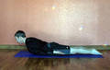 | Lying prone, forehead on the mat, arms beside head or beside body.  Exhale: Lift head and chest slightly off the mat.  Inhale: Lower body to starting position.
8 | Cat stretch | 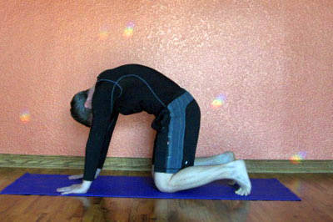 | Kneel in quadruped position, hands under shoulders, knees under hips.  Exhale: Draw spine into flexion (arching)  Inhale: Return to neutral spine  Repeat
9 | Front support | 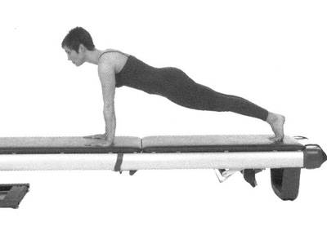 | Starting in quadruped position, trunk stable, reach one leg back and then the other into the front support position.  Option: Reach knees back into half front support position.  Exhale: Bring one leg in to kneel lightly or suspend above floor.  Inhale: return to front support position  Exhale: bring opposite leg in to kneel lightly  Inhale: Return to front support position
10 | Rest position | 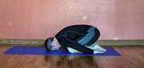 | Kneel with pelvis resting on the heels, trunk relaxed over thighs, arms reaching forward (or by side), neck released and forehead in mat.  Breathe freely, relaxing the back and expanding the rib cage with each breath.
www.getfitwithtessa.com Designed for current members of my Pilates classes.

